GobarGas Flow Monitor User Guide
Version 2: GobarGas Flow Monitor Serial Numbers 5 and 6
Updated: May 30, 2019
Ryan Thompson, Mountain Air Engineering
ryan@mtnaireng.com

The GobarGas Flow Monitor is a biogas flow logger for monitoring real-time biogas energy consumption. It is an open-source design consisting of a Waltech shield on an Arduino Due micro-controller with a Honeywell flow sensor.
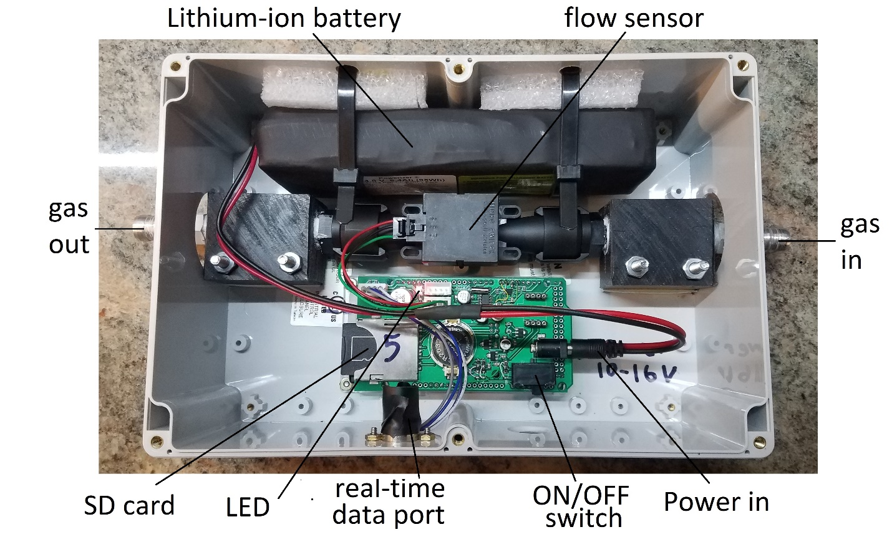
Figure 1: Inside the flow monitor

Specifications
Data storage: SD card logger
Sampling rate: Configurable, 1 minute default
Live serial data output to computer
Measurement Range: Gas Flow: 0 – 20 slpm
Flow sensor lifespan: Recommended replacement after 6 months of data logging
Power input voltage: 10–16 VDC
Battery life: 3 – 4 days
Battery: 1 Li-ion 14.8V 6.4 AH (Batteryspace product number 2263)

Procedure
1. Charge the battery before deploying:
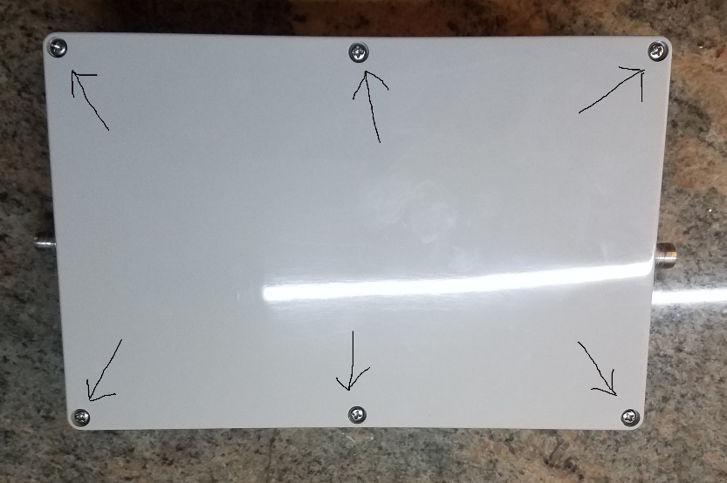
Figure 2: Remove the 6 screws to open the lid.

Remove the 6 screws to open the lid. The battery is strapped to foam pads using reusable zip ties. There is no need to remove the battery. If you do want to take out the battery, the latch of the reusable zip-ties can be opened with a flat screwdriver. If the zip-ties are cut, the zip ties should be replaced, and the battery should be re-secured before transporting or deploying the flow monitor.
Unplug the battery from the circuit board, and connect the battery to the charger (Figure 3). Use only the designated charger.
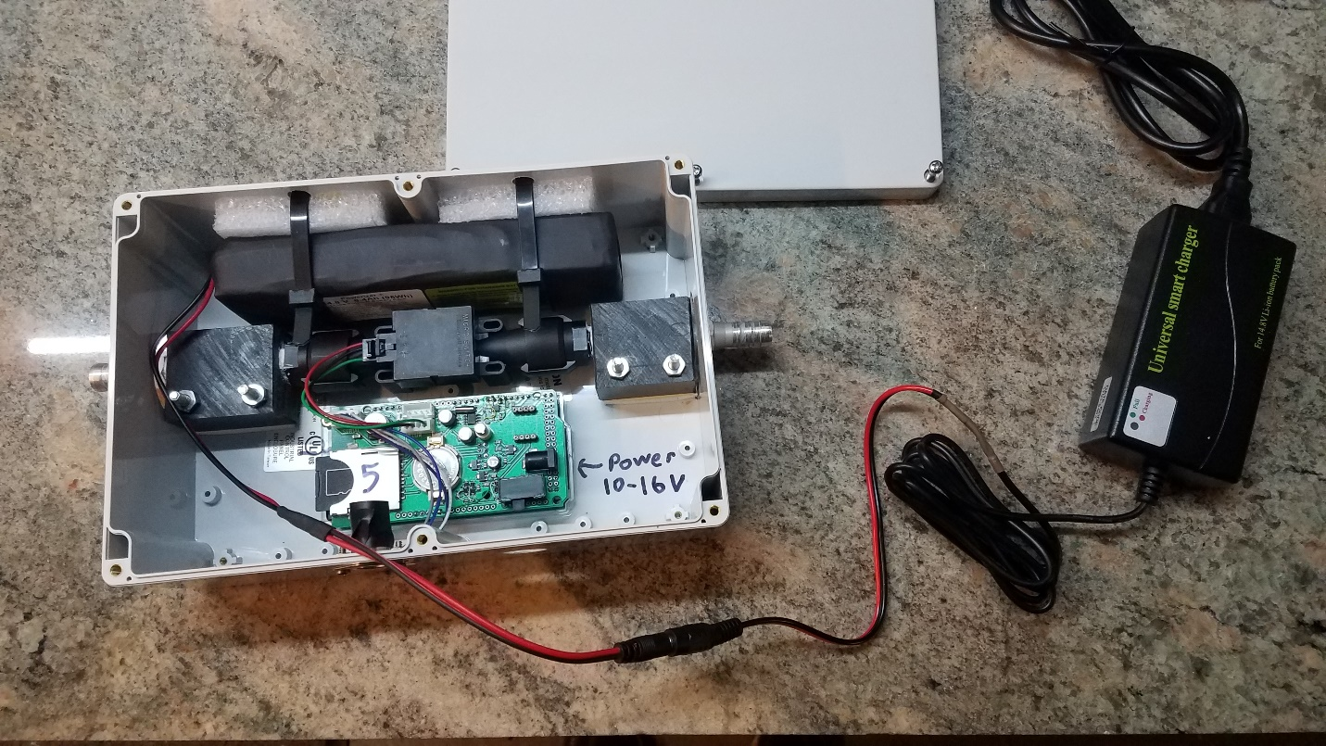
Figure 3: Unplug the battery from the barrel plug on the circuit board. Connect the battery cable to the charger cable.

When the battery is charged, plug it back into the circuit board. Make sure the power switch is off, and the LED is off, and then screw the lid back on.
2. Deployment: Connect the flow monitor in-line with the biogas hose:
To install the flow monitor, it is recommended to disconnect the biogas hose from the metering valve in the home, and reconnect this hose to the flow monitor outlet. Then use a second piece of hose to connect the metering valve to the flow monitor inlet. The flow monitor should be oriented so the gas flow is horizontal, not vertical. Do not place the flow monitor at the lowest point of the hose in order to prevent condensation from accumulating in the flow monitor.
3. Turn the flow monitor on and record the start date and time:
The power switch is accessible through a hole in the front side of the flow monitor. Use your finger, a screwdriver, or a pen to move the switch to the ON position.

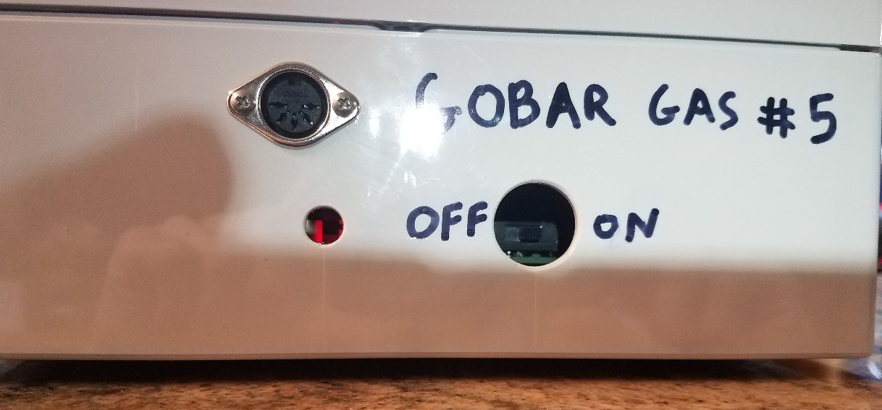
Figure 4: Power switch is in the ON position. The red LED is visible from the left peep hole.
The flow monitor has a real-time clock. The data file on the SD card is named with a time stamp (yyyy_mm_dd_hh_mm_ss.csv). It is a good idea to record the start date and time in a notebook to check the flow monitor clock.
Verify that the flow monitor is powered on by looking in the peep hole for a red LED indicator light. The LED will remain on continuously, and flash off momentarily every time it logs a measurement. If the LED flashes rapidly several times per second, then there is an SD card error (the card is missing, or dislodged, or it may require reformatting).
Optionally, the data stream can be checked by connecting the serial port to a computer with the wireless transmitter. The data stream can be read by any serial port software with port settings: 9600, 8, n, 1. The flow monitor will send a line of data once every minute.
4. Ending a measurement
Turn the flow monitor off and record the stop date and time in a notebook. Before turning off the flow monitor, you can check if it is still powered on by looking in the peep hole for the red LED. If the LED is off, the battery might be dead, and you can make a note that the data file might end before the collection time. The end of the biogas hose (approximately 2 centimeters) may need to be cut off so the hose makes a tight seal on the valve again once the flow monitor is removed.
5. Downloading Data
Open the flow monitor lid by removing the 6 screws. Eject the SD card by pushing it in (Figure 5). The SD card holder will click and eject the card. Insert the SD card into an SD card reader on a computer. Copy the desired files to another drive. Inspect the data to make sure the flow monitor is working properly before deploying it again. Close all open files on the SD card before removing it from the computer. Replace the SD card back into the flow monitor and push in until the card holder clicks to lock in place.
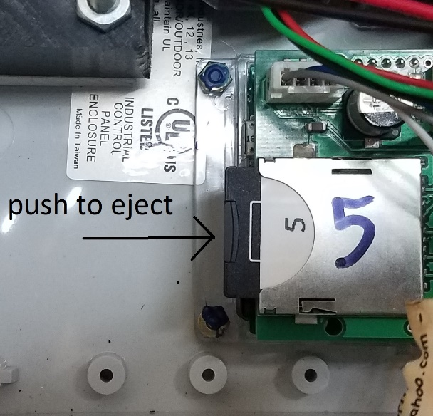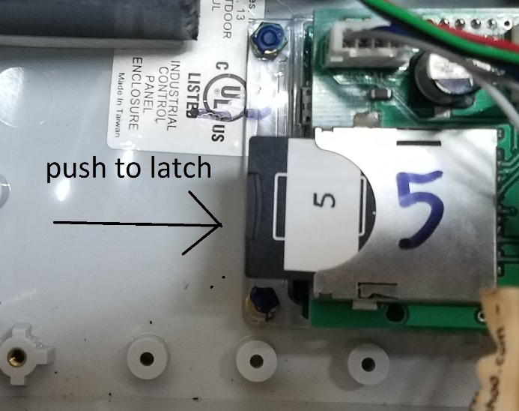

Figure 5: Left photo: The SD card is latched in place. Push in to eject it. Right photo: The SD card is not latched in place. Push to latch it. The SD card is latched when the white label aligns with the metal edge to make a half moon.

Data Output
Data files contain the following information:
#file begin.
#version: gobargas_02
#reading eemem. . . . #done
#testing sensor coms
#channels tested OK: 2
# num inputs: 2
#headers:
#A:,nan,5,8.05,0.005
#B:,nan,5,-663,12
#C:,nan,5,delay(sec),nan
#D:,nan,5,59,nan
#units:,s,5,sccm,V
time,seconds,headID,Flow,Batt
20190530 15:19:26,1,5,-8,16.5
20190530 15:20:26,61,5,12,16.5
20190530 15:21:26,121,5,16,16.5

The first 6 lines are startup diagnostics. Lines 7 – 13 are the data header.
Line 8 are the A (span) parameters.
Line 9 are the B (offset) parameters.
Lines 10 and 11 show the delay parameter.
Line 12 are the units.
Line 13 are the channel names.
The next 3 lines are the data stream:
Column 1 is the data and time.
Column 2 is the seconds elapsed since the flow monitor was powered on.
Column 3 is the header ID (serial number)
Column 4 is the gas flow rate in units of sccm (standard cubic centimeters per minute air at P=101325 Pa,T=293 K, and ρ=1.2 kg/m^3)
Column 5 is the battery voltage in Volts.

Data Processing
The flow sensor is a mass flow sensor that reports the volumetric flow as air at standard conditions. The output is calculated in the firmware as:
$$Flow=A_{Flow}*({Flow}_{raw}+B_{Flow})$$
$Flow$ = flow channel output (sccm)
$A_{Flow}$ = span parameter of flow signal (determined from calibration)
${Flow}_{raw}$ = raw signal from the flow sensor
$B_{Flow}$= offset parameter of the raw flow signal (determined from calibration)

The mass flow rate of biogas is:
$${\dot{m}}_{gas}=\frac{{\dot{V}}_{air}*ρ_{air}}{1000000*60}$$
${\dot{m}}_{gas}$= mass flow rate of biogas (kg/s)
${\dot{V}}_{air}$= flow sensor output = volumetric flow rate of air at standard conditions (sccm)
$ρ_{air}$= air density at standard conditions = 1.2 kg/m^3

The energy consumption rate (firepower) is determined by:
$$FP=\frac{{\dot{m}}_{gas}*{LHV}_{gas}}{1000000}$$
FP = firepower (Watts)
${\dot{m}}_{gas}$= biogas mass flow rate (kg/s)
${LHV}_{gas}$= heating value of biogas (MJ/kg) = 20.7±1.9 MJ/kg measured in Kavre, Nepal

The volumetric flow rate of biogas at standard conditions is:
$${\dot{V}}_{gas}=\frac{ρ_{gas}}{{\dot{m}}_{gas}}*1000000*60$$
${\dot{V}}_{gas}$= volumetric flow rate of biogas at standard conditions (sccm)
$ρ_{gas}$= biogas density at standard conditions = 1.03 kg/m^3 (assuming mol wt. = 25 g/mol)
${\dot{m}}_{gas}$= mass flow rate of biogas (kg/s)

Setup mode
The flow monitor goes into setup mode when it is sent the command “cal”:
Entering calmode
Main Menu
1: A
2: B
3: C
4: D
5: Time
6: .Digits
7: Header ID
10: Save
11: Reset
Enter>
Enter menu option 1 to update A (span) parameters.
Enter menu option 2 to update B (offset) parameters.
Enter menu option 4 to update the delay parameter. This is the number of seconds between data logs. A value of 59 results in a 1 minute sampling rate.
Enter menu option 5 to set the time
Menu option 6 sets the number of digits to the right of the decimal point that are printed for each channel.
Menu option 7, header ID, is the serial number
After parameters are updated in setup mode, menu option 10 must be selected to save the changes to memory before choosing menu option 11 to return to data logging.

Calibration
The flow sensor has a linear output. A two-point calibration check can be performed against a reference meter by recording the output during a zero-point reading (no flow), and a span point (approximately 10000 sccm). The results of the calibration check (zero drift and span calibration factor) can be used to estimate measurement uncertainty, and to correct the data when post-processing. Calibration parameters are stored in EEMEM. See Setup Mode above to update calibration parameters.
A calibration check should be performed monthly or more frequently. The Honeywell flow sensor is a hot wire filament type that is not designed for long term exposure to acidic gases such as biogas. Therefore, the sensor calibration may drift as corrosion forms on the sensor filaments. Eventually, the filaments will weaken and break, and the sensor must be replaced.

